LAB # 02
INTRODUCTION TO MSP43O MCU AND INSTALLATIONS OF HARDWARE
AND SOFTWARE TOOLS



Spring 2025
CSE-307L

Microprocessor Based System Design Lab

Submitted by: Naveed Ahmad
Registration No.: 22PWCSE2165
Class Section: B

Student Signature: ______________

Submitted to:
Engr. Shah Zada Fahim Jan
March 08, 2025

Department of Computer Systems Engineering
University of Engineering and Technology, Peshawar

Task 1
Write a program for MSP-430 which toggle P1.0 or any other pin of MSP-430 MCU Code:
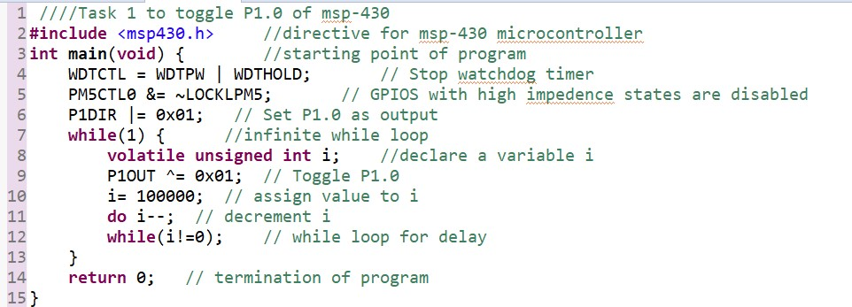

Output:

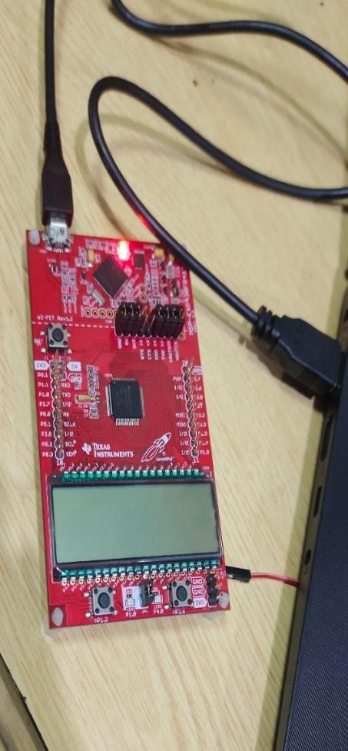

Task 2
Write a program for MSP-430 which toggle LEDs attached with P1.0 and P1.7 at the same time with different delays.
Code:
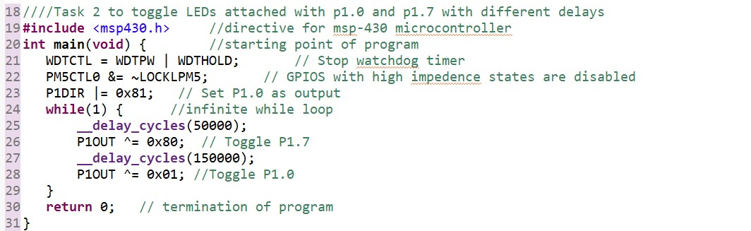

Output:
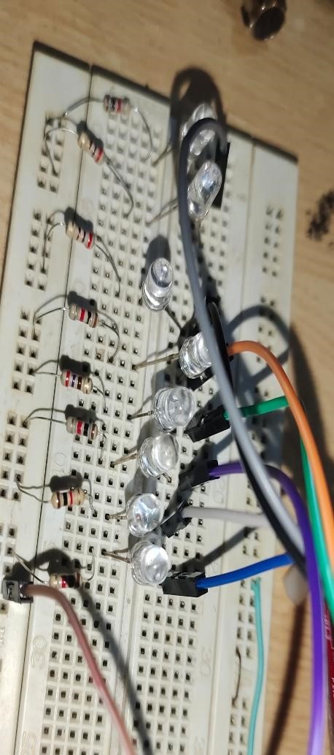

Task 3
Write a program for MSP-430 to toggle all the LEDs attached with P1 or any other PORT
Code:
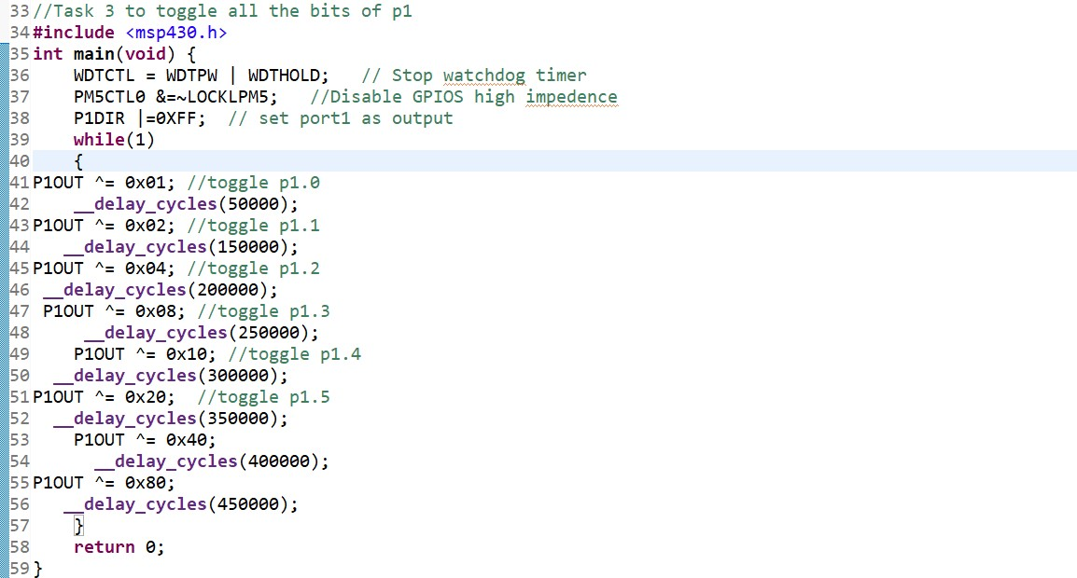

Output:
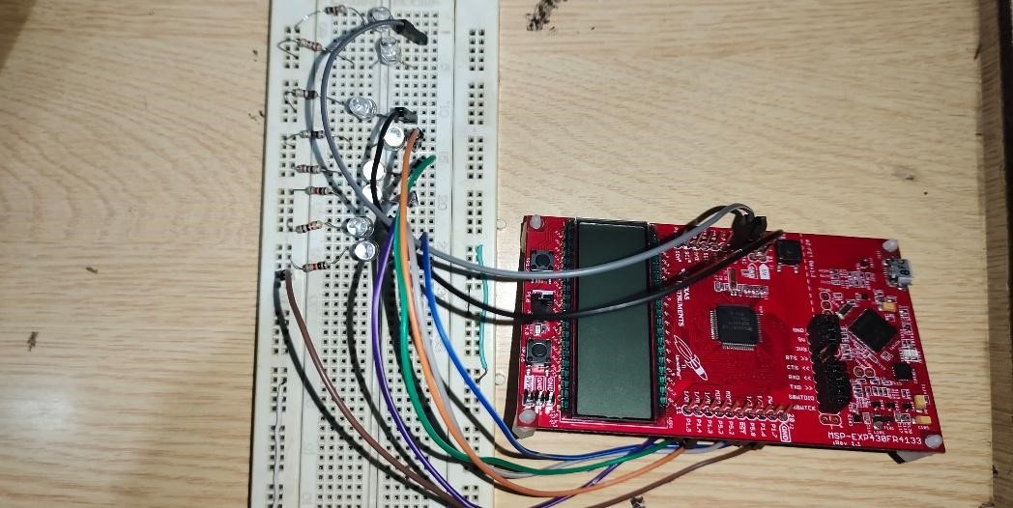

Task 4
Display the pattern using C language 00000001 00000010 00000100 …. 10000000 00000001 00000010 Continuously Code:
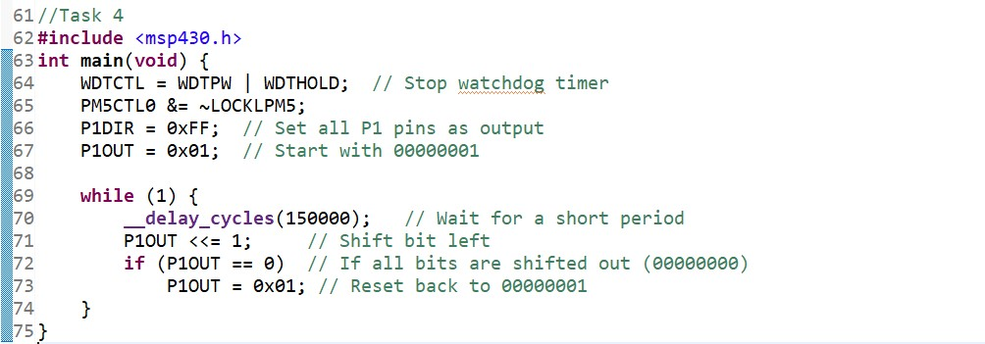

Output:
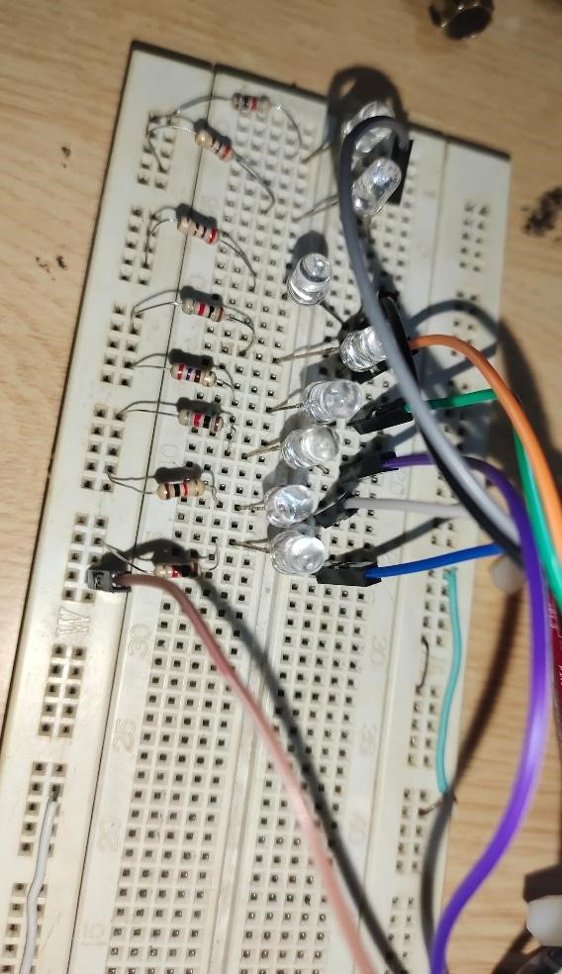

*****END OF LAB 02*****

